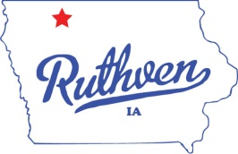
City of Ruthven, Iowa
1305 Gowrie St.
Ruthven, IA 51358
Phone: (712) 837-5355
Fax: (712) 837-3314
“Come for a Visit, Stay for a Lifetime!”
AGENDA
SPECIAL CITY COUNCIL MEETING
(IN COUNCIL CHAMBERS)
TUESDAY – May 10, 2021 – 6:30 PM

- HIRE LIFEGUARDS

- MOTION TO ADJOURN

Mayor
David J. Kirk

Mayor Pro Tem-Council Member
Jay Schoning

Council Members
Mitch Anderson
Dustin Johnson
Marcelle Simington
Terrence Williams

City Clerk
Jessica Schneider

Deputy City Clerk
Anesa McGregor

Public Works Director
David Conlon

Street Superintendent
Michael Loder

City Attorney
David Stein Jr.

